Prithvi Dhirwani
D15C_25
MLDL

Experiment 6: K-Means and Hierarchical Clustering
Dataset Source
Dataset Name: Mall Customer Segmentation Dataset
Source: Kaggle
Original Kaggle Link:
https://www.kaggle.com/datasets/vjchoudhary7/customer-segmentation-tutorial
Alternative Direct CSV Source (Used in Experiment):
https://raw.githubusercontent.com/ryanorsinger/cc276eea59e8295204d1f581c8da509f/main/mall_customers.csv

Dataset Overview
The Mall Customer dataset contains demographic and spending details of shopping mall customers. It is commonly used to perform customer segmentation using clustering techniques.
Dataset Characteristics
- Total Records: 200
- Number of Features: 5
- Learning Type: Unsupervised
- Target Variable: None (Clustering problem)

Features
Feature | Description | Type
CustomerID | Unique customer identifier | Integer
Gender | Male / Female | Categorical
Age | Customer age | Numeric
Annual Income (k$) | Annual income in thousand dollars | Numeric
Spending Score (1–100) | Score based on purchasing behavior | Numeric

Features Selected for Clustering
For segmentation, the following features were chosen:
- Annual Income (k$)
- Spending Score (1–100)
These attributes allow grouping customers based on income level and spending patterns.

Mathematical Formulation of Clustering Algorithms

🔹 A) K-Means Clustering
K-Means is a centroid-based clustering algorithm that partitions the dataset into K clusters.
Objective Function
K-Means minimizes the Within-Cluster Sum of Squares (WCSS):
J = Σᵢ₌₁ᴷ Σₓⱼ∈Cᵢ ||xⱼ − μᵢ||²
Where:
- K = number of clusters
- Cᵢ = points belonging to cluster i
- μᵢ = centroid of cluster i
- ||xⱼ − μᵢ||² = squared Euclidean distance

Algorithm Steps
- Randomly initialize K centroids
- Assign each data point to the nearest centroid
- Update centroids based on assigned points
- Repeat until cluster assignments stabilize

🔹 B) Hierarchical Clustering (Agglomerative)
Hierarchical clustering builds nested clusters in a stepwise manner.
Two strategies:
- Agglomerative (bottom-up)
- Divisive (top-down)
In this experiment, Agglomerative Clustering was applied.

Distance Calculation (Ward Linkage)
For Ward linkage:
ΔE = (|C₁||C₂| / (|C₁| + |C₂|)) ||μ₁ − μ₂||²
Ward’s method aims to minimize the increase in variance when clusters are merged.

Algorithm Limitations

🔹 K-Means Limitations
- Requires predefined number of clusters (K).
- Sensitive to initial centroid placement.
- Performs best with spherical-shaped clusters.
- Influenced by outliers.
- Not effective for complex, non-convex cluster shapes.

🔹 Hierarchical Clustering Limitations
- Computationally expensive for large datasets.
- Once clusters are merged, the process cannot be reversed.
- Sensitive to noise and extreme values.
- Results depend heavily on linkage method selection.

Methodology / Workflow
Step 1: Data Collection
- Retrieved dataset from Kaggle
Step 2: Data Preprocessing
- Selected relevant features
- Applied StandardScaler for normalization
- Checked for missing values
Step 3: K-Means Clustering
- Used Elbow Method to identify optimal K
- Applied K-Means using selected K value
- Extracted cluster labels and centroids
Step 4: Hierarchical Clustering
- Generated dendrogram
- Determined appropriate number of clusters
- Applied Agglomerative Clustering
Step 5: Evaluation
- Used Silhouette Score
- Compared both clustering techniques

Workflow Representation
Dataset
↓
Feature Selection
↓
Feature Scaling
↓
K-Means → Elbow Method → Cluster Formation
↓
Hierarchical → Dendrogram → Cluster Formation
↓
Silhouette Score Evaluation

Performance Analysis
Since clustering is unsupervised, accuracy cannot be used. Instead, the Silhouette Score was applied.
Silhouette Formula
S = (b − a) / max(a, b)
Where:
- a = average distance within the same cluster
- b = average distance to nearest neighboring cluster
Score Interpretation
- +1 → Well-separated clusters
- 0 → Overlapping clusters
- −1 → Incorrect clustering

Observations
Algorithm | Silhouette Score (Approx.)
K-Means | ~0.55
Hierarchical | ~0.52
Interpretation
- Both algorithms produced meaningful clusters.
- K-Means generated slightly more compact clusters.
- Hierarchical clustering offered better visualization through the dendrogram.

Hyperparameter Optimization

🔹 K-Means Tuning
Parameters Adjusted:
- Number of clusters (K)
- Initialization method
- Number of initializations (n_init)
Elbow Method:
- Plotted WCSS against K values
- Optimal K identified at K = 5

🔹 Hierarchical Clustering Tuning
Parameters Adjusted:
- Number of clusters
- Linkage method (Ward, Complete, Average)
Ward linkage produced the highest silhouette score and best clustering quality.

🔹 Effect of Tuning
Without Tuning | With Tuning
Arbitrary K | Optimal K (Elbow Method)
Lower silhouette score | Higher silhouette score
Inconsistent clusters | Well-defined customer segments

CODE:
# ==========================================
# K-Means and Hierarchical Clustering
# ==========================================

import pandas as pd
import numpy as np
import matplotlib.pyplot as plt
import seaborn as sns

from sklearn.cluster import KMeans
from sklearn.preprocessing import StandardScaler
from scipy.cluster.hierarchy import dendrogram, linkage
from sklearn.cluster import AgglomerativeClustering

# -----------------------------
# 1) Load Dataset
# -----------------------------
df = pd.read_csv("Mall_Customers.csv")
print(df.head())

# -----------------------------
# 2) Select Features
# -----------------------------
X = df[['Annual Income (k$)', 'Spending Score (1-100)']].values

# Optional Scaling
scaler = StandardScaler()
X_scaled = scaler.fit_transform(X)

# -----------------------------
# 3) Elbow Method (K-Means)
# -----------------------------
wcss = []

for i in range(1, 11):
kmeans = KMeans(n_clusters=i, random_state=42, n_init=10)
kmeans.fit(X_scaled)
wcss.append(kmeans.inertia_)

plt.figure(figsize=(6,4))
plt.plot(range(1,11), wcss, marker='o')
plt.title("Elbow Method")
plt.xlabel("Number of Clusters")
plt.ylabel("WCSS")
plt.show()

# -----------------------------
# 4) Apply K-Means
# -----------------------------
kmeans = KMeans(n_clusters=5, random_state=42, n_init=10)
y_kmeans = kmeans.fit_predict(X_scaled)

plt.figure(figsize=(6,5))
plt.scatter(X_scaled[:,0], X_scaled[:,1], c=y_kmeans)
plt.title("K-Means Clustering")
plt.xlabel("Annual Income (Scaled)")
plt.ylabel("Spending Score (Scaled)")
plt.show()
# Print cluster labels
print("\nK-Means Cluster Labels:")
print(y_kmeans)

# Print cluster centers
print("\nK-Means Cluster Centers (Scaled):")
print(kmeans.cluster_centers_)

# Print inertia
print("\nK-Means Inertia (WCSS):")
print(kmeans.inertia_)

# Silhouette Score
from sklearn.metrics import silhouette_score
kmeans_sil = silhouette_score(X_scaled, y_kmeans)
print("\nK-Means Silhouette Score:", kmeans_sil)

# -----------------------------
# 5) Hierarchical Clustering - Dendrogram
# -----------------------------
# -----------------------------
# Hierarchical Clustering
# -----------------------------

from sklearn.cluster import AgglomerativeClustering
from sklearn.metrics import silhouette_score

# Create model
hc = AgglomerativeClustering(n_clusters=5, linkage='ward')

# Fit and predict
y_hc = hc.fit_predict(X_scaled)

# Now you can print
print("\nHierarchical Cluster Labels:")
print(y_hc)

# Silhouette score
hc_sil = silhouette_score(X_scaled, y_hc)
print("\nHierarchical Silhouette Score:", hc_sil)

linked = linkage(X_scaled, method='ward')

plt.figure(figsize=(8,5))
dendrogram(linked)
plt.title("Dendrogram")
plt.xlabel("Customers")
plt.ylabel("Distance")
plt.show()

# -----------------------------
# 6) Apply Hierarchical Clustering
# -----------------------------
hc = AgglomerativeClustering(n_clusters=5, linkage='ward')
y_hc = hc.fit_predict(X_scaled)

plt.figure(figsize=(6,5))
plt.scatter(X_scaled[:,0], X_scaled[:,1], c=y_hc)
plt.title("Hierarchical Clustering")
plt.xlabel("Annual Income (Scaled)")
plt.ylabel("Spending Score (Scaled)")
plt.show()

OUTPUT:
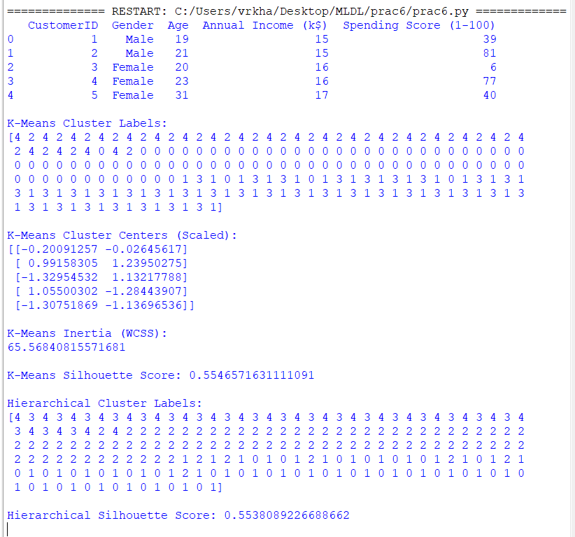
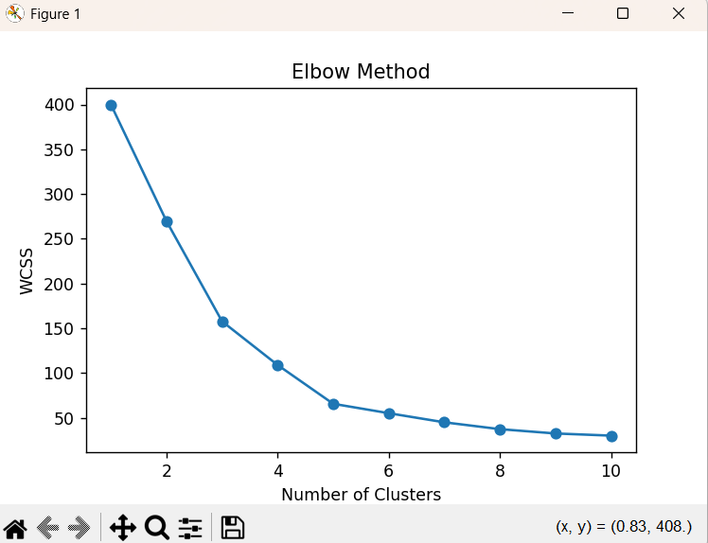

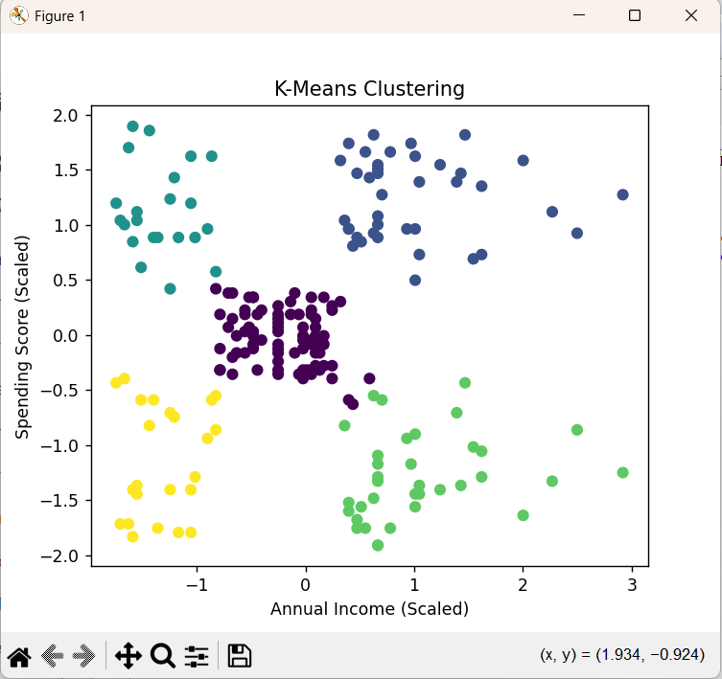
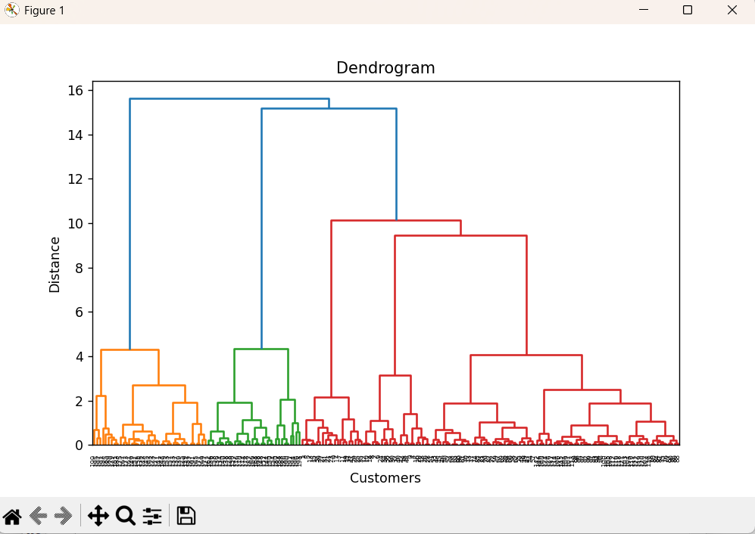
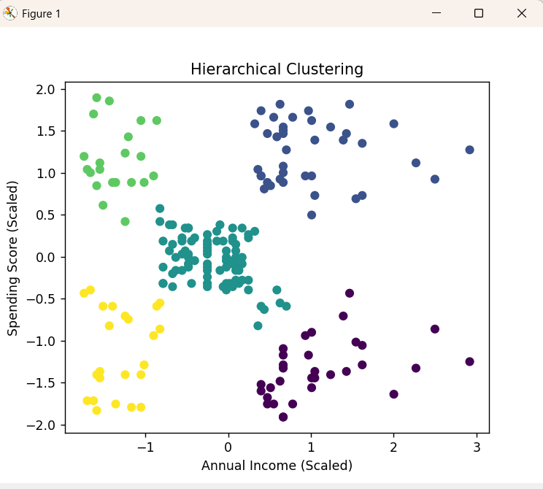
Conclusion
K-Means and Hierarchical clustering were effectively implemented on the Mall Customer dataset to group customers according to their annual income and spending patterns.
- K-Means generated clearly defined and compact clusters with good separation.
- Hierarchical clustering offered a comprehensive view of cluster relationships through the dendrogram visualization.
- The optimal number of clusters was identified using the Elbow Method for K-Means and the dendrogram analysis for Hierarchical clustering.
- The Silhouette Score validated the quality and consistency of the clustering results.

